**Bridge Farm 2018-19: A journey into the dark centre!**

The 2018 summer season saw the opening of the seventh trench at the intriguing Romano-British settlement site at Bridge Farm, near Barcombe Mills.

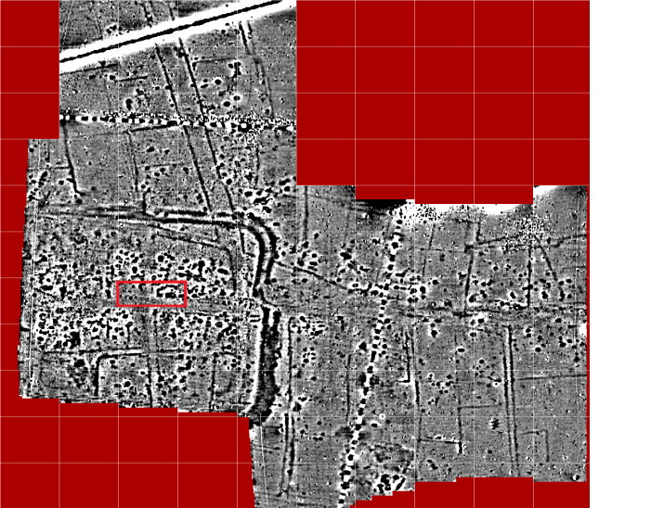

*Trench 7 on the geophysics image*

**Trench 7** is located in the very centre of the area enclosed by the 2nd century double-ditch defences and it was hoped that this 45 by 20 metre area over a central crossroads would reveal evidence of the formal hub of the settlement. However we constantly reminded that this site represents over 300 years of activity and what remains in this area seems once again mainly feature industrial activity. This consist of a collection of very large, deep pits, areas of fired clay, several series of postholes with large flint and chalk packing all containing a dark brown sandy silt suggesting a high charcoal content. Some of the postholes do appear to be in rows but so far lack the corresponding row that would be needed for a rectangular structure. They are certainly not as obviously related as the 13 postholes of the building revealed in 2014.

An area of the road from Pevensey was revealed at only 200mm below the current ground level in the south-eastern corner of the trench. The upper layer of this consisted of pebbles and small nodules of Downland flint which had been disturbed by ploughing. Beneath this was a compressed sandy layer of flint gravels forming the main base structure of the road. It is remarkable that this had survived at such a shallow depth and no trace was found anywhere else along the trench having been presumably ploughed and/or robbed out.

Of the many large pits one in the northwest corner of the trench proved to be not only multi-layered but very deep. As it was truncated by two baulks it needed the adjacent spoil heaps to be removed before excavation could be completed and it hoped to get this prepared for the 2020 season. Most of the other pits and postholes discovered in 2018 were half-sectioned and recorded and then fully excavated in 2019. This task was complicated in many cases by the larger pits being cut by later pits and gulleys.

One area was of particular interest as a deposit of fired clay appeared surrounded by lumps of chalk and fire-cracked flint nodules. The feature had the appearance of some kind of hearth with the presence of chalk leading us to think that it may be the remains of a simple clamp-type lime kiln. The only previous notable occurrence of chalk at Bridge Farm was in the walls of the well excavated in 2017 in Trench 6 but the structural use of chalk in a fired environment seems less likely. Our initial thoughts were called into question on discovery of 2 very large postholes adjacent to the ‘Pevensey’ road which had large blocks of chalk used in addition to flint nodules as post packing. The eastern of these (PH1) also had a large fragment of a German lava quern stone at the base presumably used as a pad to support the post. Unlike the 13 postholes from 2014 those in this area appeared to have had their posts removed rather than left to rot in-situ.

A circular black area revealed what appeared to be fragments of a burnt clay wall around it as the very dark fill was removed. In 2018 we thought we may have discovered a kiln of some kind but further excavation in 2019 revealed yet another very deep pit below causing more debate. This feature is still at the half-sectioned phase so hopefully more will be gained as full excavation takes place in 2020. The extensive range of large pits has at present left us a little puzzled especially as we are excavating at the centre of the 2nd century enclosure where we expected a more formal arrangement.

 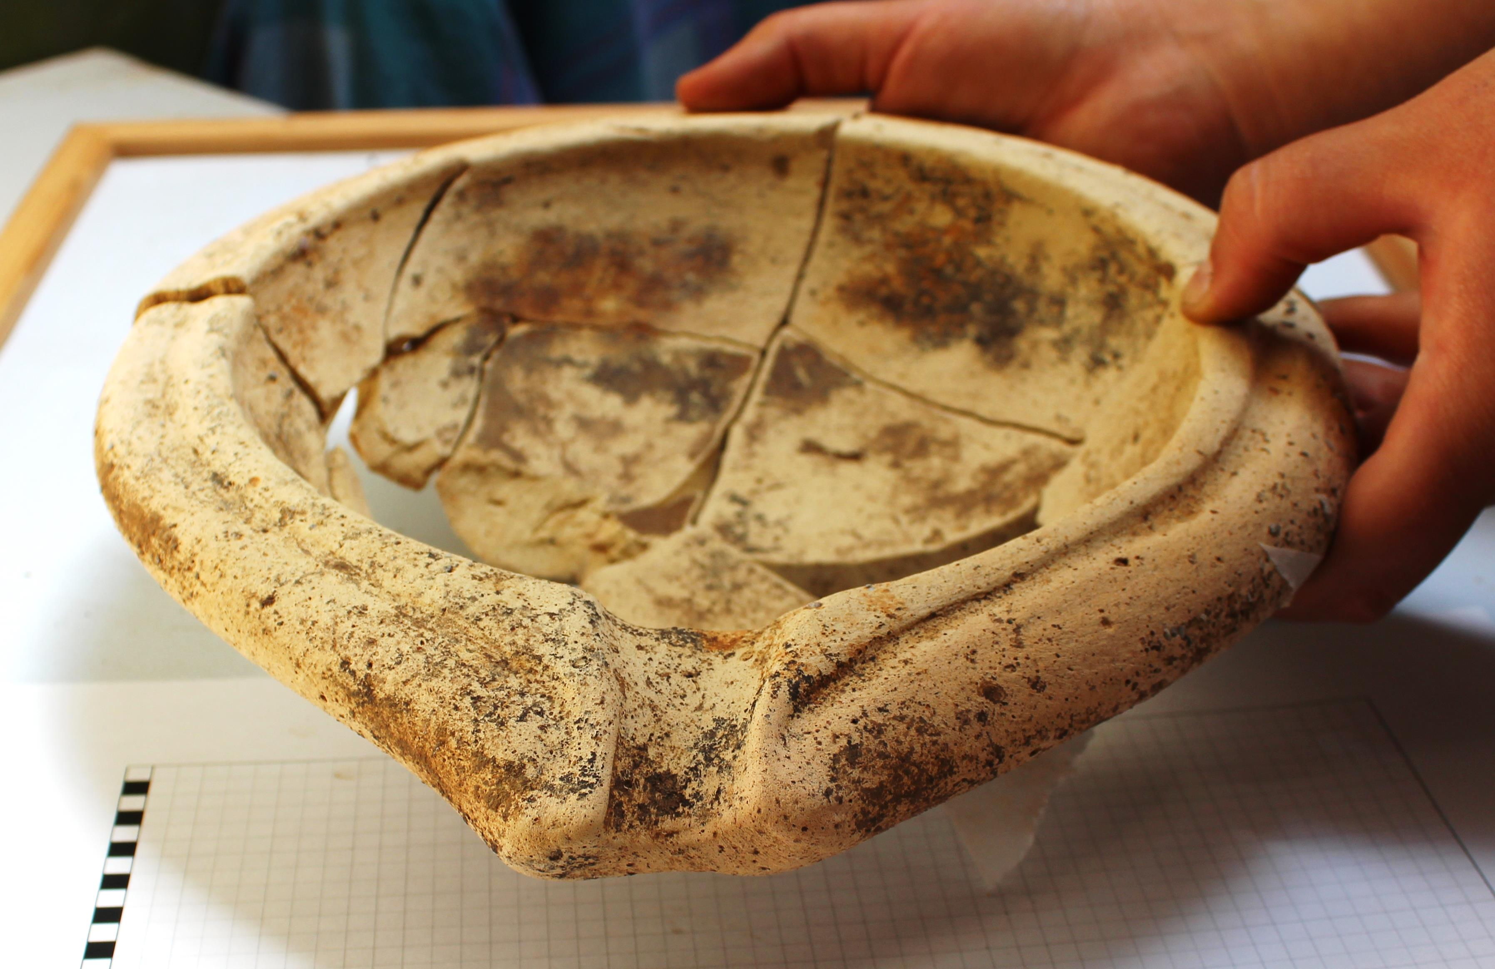

*A decorated samian bowl sherd An almost complete mortarium*

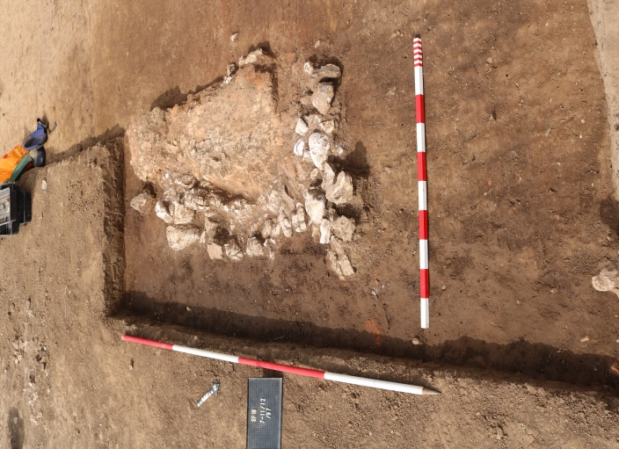 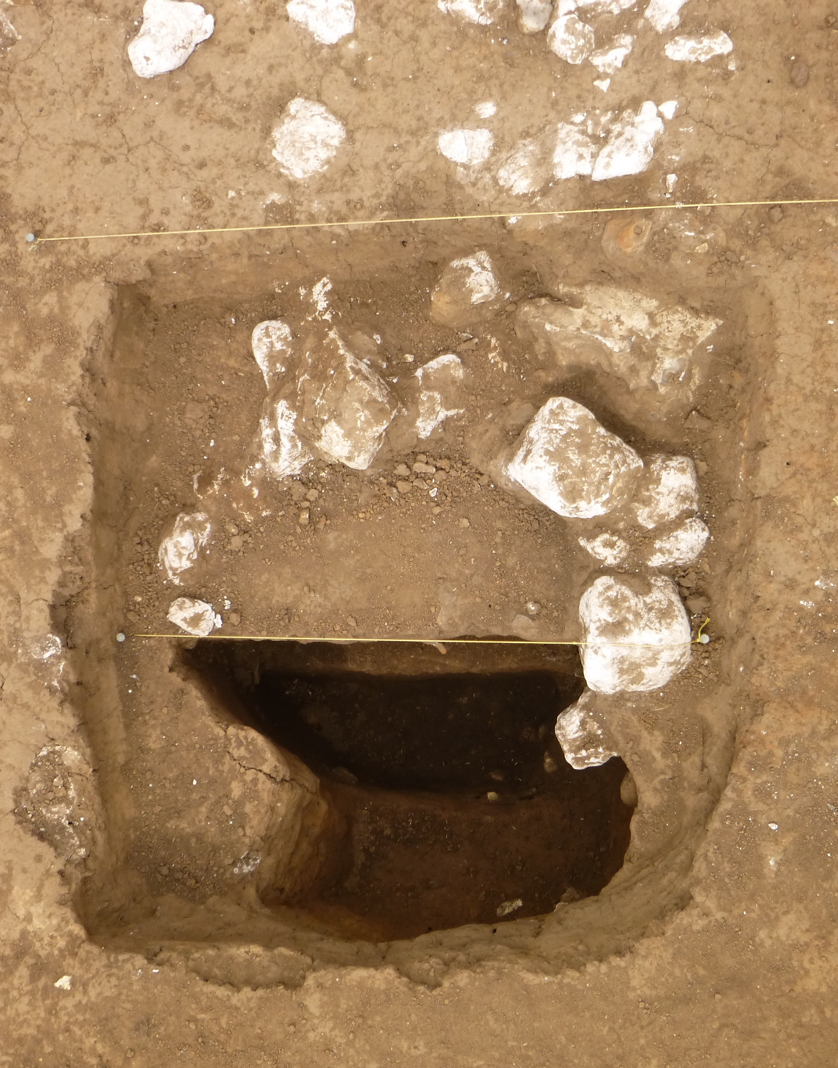

*A possible hearth surrounded by chalk One the large postholes with chalk packing*

From the initial cleaning-back of the trench surface a large and varied assemblage of pottery was collected, totalling over 28,000 sherds in 2018-19, with a greater percentage of fine wares than seen from previous trenches. This included a good quantity of samian, some with embossed decoration, maker’s marks and scratched graffiti.

Close to the chalk-lined hearth was a pile of black colour-coated white fineware beaker sherds with a number of large amphora sherds nearby. We had more mortaria sherds than before including one almost complete mortarium in a light buff/cream fabric and more amphora sherds some with maker’s stamps. As this has proved to be at least a 3 year trench we will have to wait before commissioning the pottery analysis.

As well as pottery we have found a variety of bronze dress accessories including some fibula brooches, pins and jewellery fragments. The brooches are quite fine which suggests they come from the earlier phases of occupation. We have also recovered a few coins to give us some clues as to the phase of activity we are excavating and whereas in Trench 6 at the northeast corner of the settlement a larger assemblage of coins was dominated by late 3rd century radiates and 4th century House of Constantine issues here the coins seem much earlier dating mostly to the 2nd century.

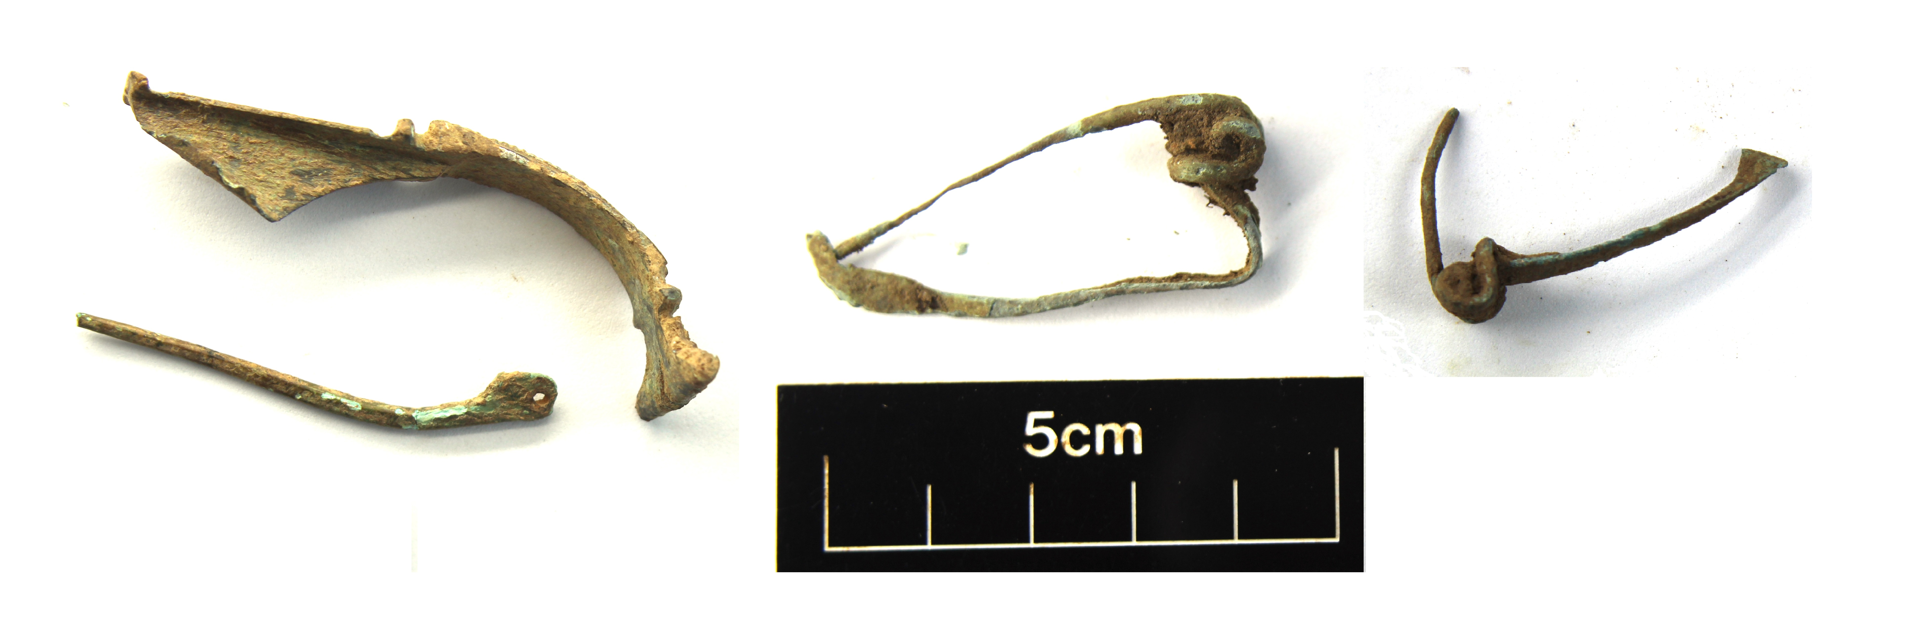

*3 of the fibula brooches recovered in 2019*

Could this imply a movement away and towards the northeast from this area during the later Roman period? Are the deep pits a result of subsequent plundering of materials from this area? In 2020 we will dig further into the features we have revealed and excavate the north-eastern section of Trench 7 where we hope to find some clues to the enigma of this area and possibly some more large postholes to align with those excavated in 2019.

For more details of both past, present and future activity at Bridge Farm visit our website [www.culverproject.co.uk](http://www.culverproject.co.uk).

David Millum, MCIfA, ©CAP December 2019